[Start/Stop and Restart Jenkins service on Windows](https://stackoverflow.com/questions/14869311/start-stop-and-restart-jenkins-service-on-windows)

**I have extracted zip file and installed Jenkins on Windows 7 successfully. Jenkins runs at http://localhost:8080/ well. I want to stop Jenkins service from console. How can I do that? What's the way to start and restart through console/command line?**

* **On Windows, if you open up Services (from the start menu search) or navigate to C:\ProgramData\Microsoft\Windows\Start Menu\Programs\Administrative Tools and then open Services > Scroll down to find Jenkins in the list and you may start/stop it via the UI dialogue box. Or as the list of answers suggest, the command line is a perfectly nice way to do it too.**

**Open Console/Command line --> Go to your Jenkins installation directory (very likely cd   
"C:\Program Files\Jenkins\"). Execute the following commands respectively:**

**to stop:  
.\jenkins.exe stop**

**to start:  
.\jenkins.exe start**

**to restart:  
.\jenkins.exe restart**

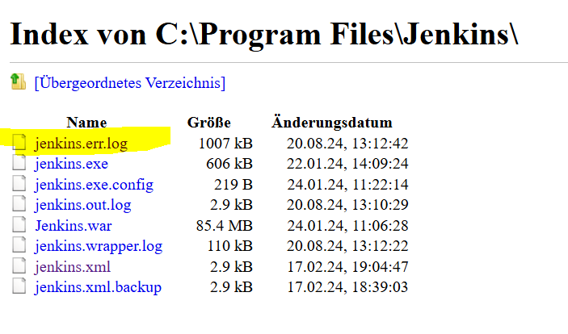

In Jenkins.err.log file contains the Jenkins login password as shown below:

Jenkins initial setup is required. An admin user has been created and a password generated.  
Please use the following password to proceed to installation:  
c51a111bd6fe414f9ccfd15848e72ef9  
This may also be found at: C:\ProgramData\Jenkins\.jenkins\secrets\initialAdminPassword

On browser 🡪 localhost:8080 🡪 [Sign in [Jenkins]](http://localhost:8080/login)

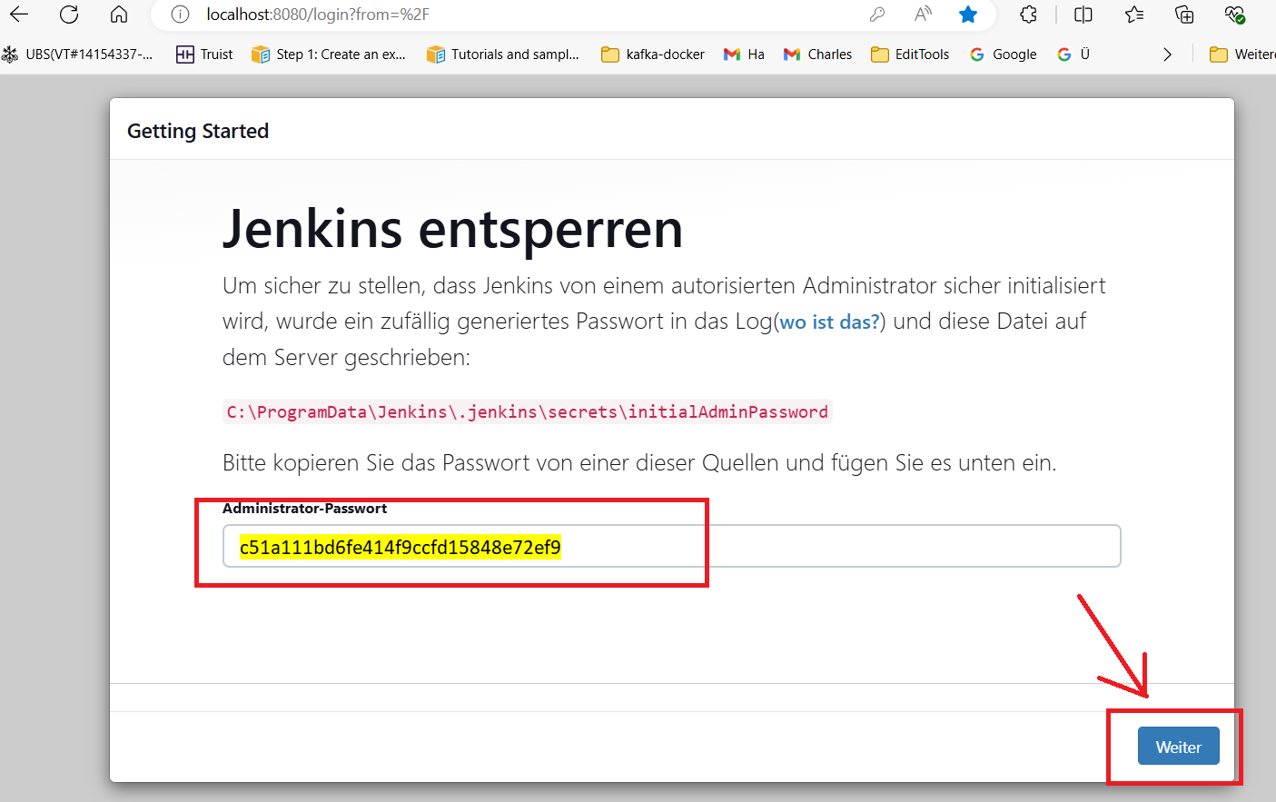

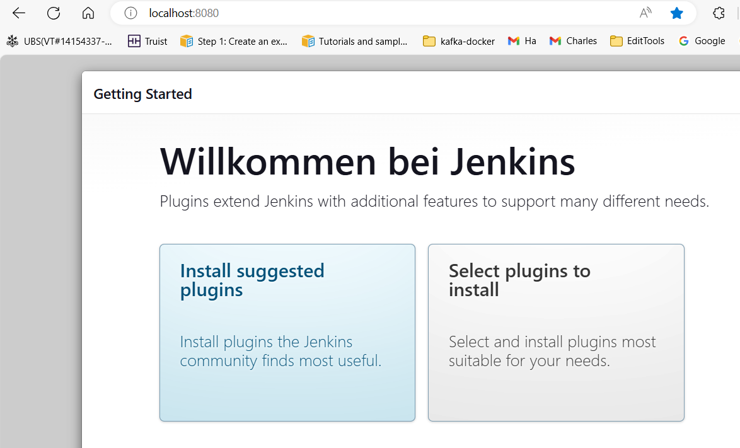

Udemy Course

Repository URL: <https://github.com/wardviaene/jenkins-cours>

Installation methods

* On the Cloud using docker (works on AWS, DigitalOcean, Google Cloud, Azure) •
* [www.virtualbox.org](http://www.virtualbox.org) can run ubuntu in a VM locally
* [www.vagrantup.com](http://www.vagrantup.com) together with virtualbox can spin up a running ubuntu instance in minutes (see my other DevOps course for an introduction to Vagrant)
* Docker for windows can run docker on a windows PC (<https://docs.docker.com/docker-for-windows/>)
* Docker for mac can run docker on a mac ([https://docs.docker.com/docker-for-mac/)](https://docs.docker.com/docker-for-mac/)J)
* Jenkins is written in java, so you can also run it without docker on any OS Still I recommend docker for this course
* Even when using linux and docker, you can still run jenkins slaves on Microsoft Windows to build applications that need a Microsoft Windows OS

[Start/Stop and Restart Jenkins service on Windows](https://stackoverflow.com/questions/14869311/start-stop-and-restart-jenkins-service-on-windows)

[Ask Question](https://stackoverflow.com/questions/ask)

I have downloaded "jenkins-1.501.zip" from <http://jenkins-ci.org/content/thank-you-downloading-windows-installer> .

I have extracted zip file and installed Jenkins on Windows 7 successfully. Jenkins runs at http://localhost:8080/ well. I want to stop Jenkins service from console. How can I do that? What's the way to start and restart through console/command line?

* On Windows, if you open up Services (from the start menu search) or navigate to C:\ProgramData\Microsoft\Windows\Start Menu\Programs\Administrative Tools and then open Services > Scroll down to find Jenkins in the list and you may start/stop it via the UI dialogue box. Or as the list of answers suggest, the command line is a perfectly nice way to do it too.

Open Console/Command line --> Go to your Jenkins installation directory (very likely cd   
"C:\Program Files\Jenkins\"). Execute the following commands respectively:

**to stop:**  
.\jenkins.exe stop

**to start:**  
.\jenkins.exe start

**to restart:**  
.\jenkins.exe restart

**To stop Jenkins** Please avoid shutting down the Java process or the Windows service. These are not usual commands. Use those only if your Jenkins is causing problems.

Use Jenkins' way to stop that protects from data loss.

http://[jenkins-server]/[command]

where [command] can be any one of the following

* exit
* restart
* reload

Example: if my local PC is running Jenkins at port 8080, it will be

http://localhost:8080/exit

So by default you can open CMD and write

java -jar jenkins.war

But if your port 8080 is already is in use,so you have to change the Jenkins port number, so for that open Jenkins folder in Program File and open Jenkins.XML file and change the port number such as **8088**

Now Open CMD and write

java -jar jenkins.war --httpPort=8088

**To start Jenkins from command line**

1. Open command prompt
2. Go to the directory where your war file is placed and run the following command:

java -jar jenkins.war

**To stop**

Ctrl + C

**To Start Jenkins through Command Line**

1. Run CMD with admin
2. You can run following commands

"net start servicename" to start

"net restart servicename" to restart

"net stop servicename" to stop service

for more reference <https://www.windows-commandline.com/start-stop-service-command-line/>

jenkins.exe stop

jenkins.exe start

jenkins.exe restart

These commands will work from cmd only if you run CMD with admin permissions

Small hints for routine work.

Create a bat file, name it and use for exact run/stop/restart Jenkins service

#!/bin/bash

# go to Jenkins folder

cd C:\Program Files (x86)\Jenkins

#to stop:

jenkins.exe stop

#to start:

#jenkins.exe start

#to restart:

#jenkins.exe restart

To run/stop/restart Jenkins in Windows, you can make a bat file with .bat extension

@echo off

rem Go to Jenkins folder

cd "C:\Program Files\Jenkins"

rem To stop Jenkins

jenkins.exe stop

rem To start Jenkins

rem jenkins.exe start

rem To restart Jenkins

rem jenkins.exe restart

rem is for commenting line in windows. Remove rem to execute the particular line.

Run the .bat file as ./your_file_name.bat

Inspired By: Roman Denisenko (<https://stackoverflow.com/a/59500670/13237892>)